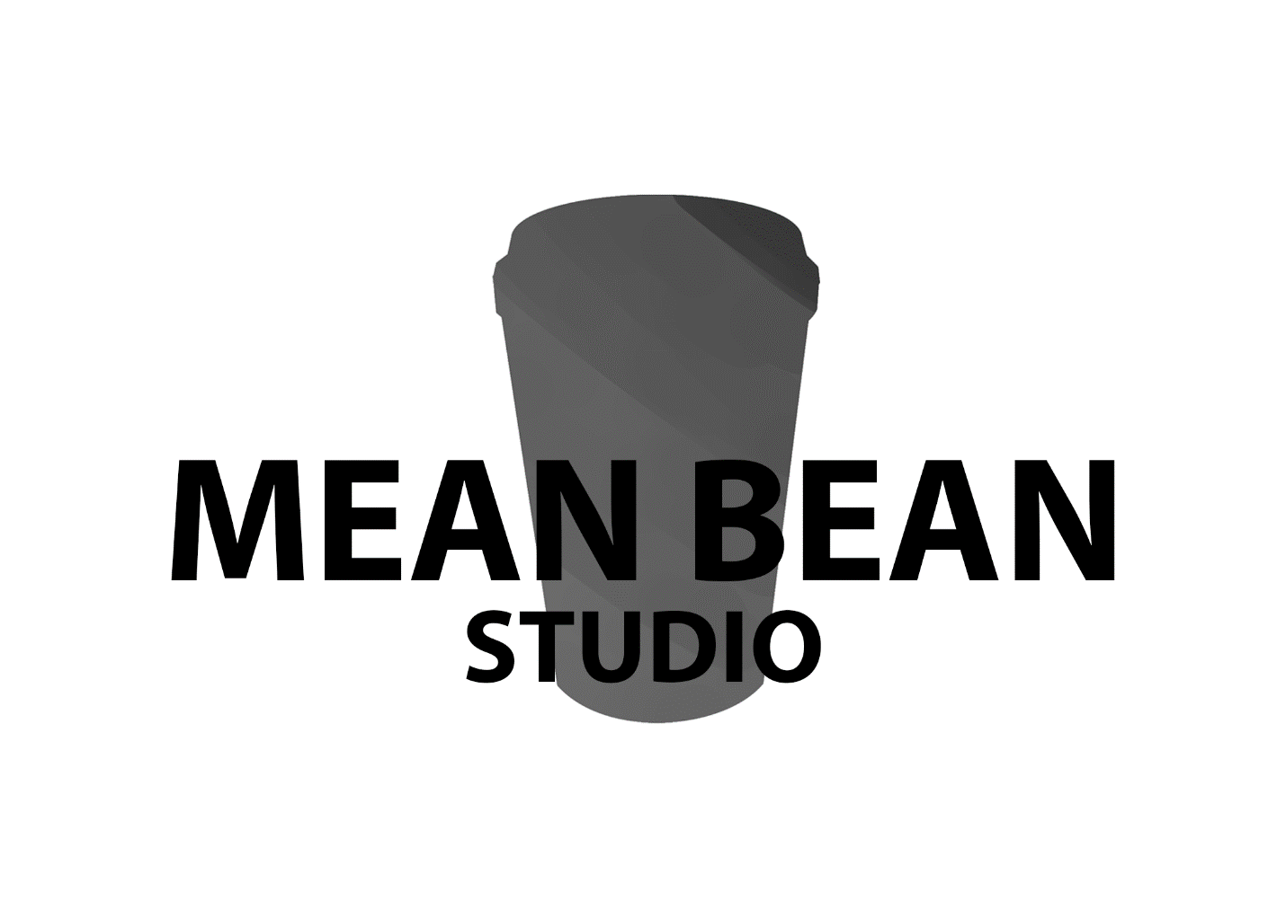

Luke, Will, Aiden, Domenic, Pasqual, Tarek

**Game design document**

Contents

Synopsis 3

Target audience 3

Competitors 3

Tool list 3

Core pillars/ experiences 4

Goals/objectives 4

Game mechanics 4

Rules 5

Game loops 5

Game economy 6

Levels 7

Npcs, enemies and hazards 7

Objects/ items 8

Unlocks/ purchases 8

Other known content. 8

# **Document Overview**

The following document is the game design for Coffee-mania.

Anything that is highlighted yellow is subject to change or TBD.

Anything that is highlighted green has been recently changed.

# **Synopsis**

The game that was chosen is an endless runner that allows the player to earn real life discounts.

The game will have 3 metaphorical “lanes”. The left right and middle lane. Obstacles will cover all or some of the lanes. The longer the player plays the game the faster the speed of the game will increase. Obstacles will be more frequent and the player will have to make faster decisions.

# **Target audience**

The target audience as the client has said are “young, adventurous, who enjoy the fine things in life.”

The app will mainly be targeting people at the age range of 16 to 45 years with more focus on high school – university students (GenZ) and other young adults (Gen Y). Studies show that 61% of GenZ and 53% of GenY drink coffee, this is followed by GenX with 36%. This study was done in Australia.

<https://mccrindle.com.au/insights/blogarchive/australian-attitudes-towards-coffee/>

# **Competitors**

* Temple run
* Sonic dash
* Subway surfers

Although all three are similar to the game we’re making none of them offer real life rewards. Al of them offer in game purchases including currency and skins**. If the team has time** we can create more skins for the players. The difference these games are the lane systems, in sonic dash and Subway surfers the player has to **swipe the screen** to change lanes while temple run has a **tilt system**.

Our game was going to have the tilt system if we were going to make the game on a phone.

However the decision is available for the client.

# **Tool list**

* Photoshop
* Zbrush
* Maya
* Substance painter
* Substance designer
* Unity
* Word

# **Core pillars/ experiences**

Competitive: players compete against each other to get better rewards

# **Goals/objectives**

* Get a higher score to get better rewards
* Earn enough bean to redeem real life rewards.

# **Game mechanics**

Moving

* **Side to side controls:** when the player presses “a” or “d” the character strafes on that direction
* **Turns:** when the player presses the arrow keys (left or right) the character turns 90 degrees in that direction
* **Jump:** when the player presses the “space bar” the character jumps
* **Slide:** when the player presses the “s” key the character slides.

Pick-Ups: Does something when the player runs into the object.

* **Coffee bean:** adds one currency to the player’s overall account
* **Sugar:** speeds the player character up X1.5 for 10 seconds (player becomes invincible)
* **Ice cubes:** slows down the level speed for 10 seconds. (may be subject to change)
* **Net**: allows the player to catch all nearby coffee beans without having to run into them.
* **Barista knife:** when the player picks up this it allows the player to ignore 1 obstacle.
* **Milk:** score multiplier
* **Tea:** invert controls for 10-15 seconds, if completed give the player an extra 20 beans.
* **Coffee cannon :** once the player has collected (x) the player can activate Beanbo’s coffee cannon which destroys all obstacles in the path

# **Rules**

* There can never be 2 turns corners in a row, there must always be a chunk before a turn chunk
* The player only has one life
* The player cannot move through obstacles unless he has the barista knife or is under the effect of the sugar speed boost.
* The player can trip slowing down the level for a time and the chaser appears on screen again
* The player can never have more then 2 coupons at a time.
* The player can only turn left or right
* When the player turn when there is no turn, the character stumbles and macino appears on screen giving the player another chance.
* The pasth is 6 meters wide
* The bean cannon cannot destroy turns. Only obstacles on the path.

# **Game loops**

**Rewards Moment to Moment Gameplay**

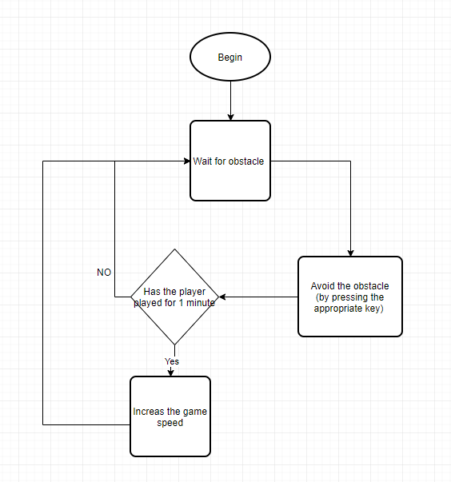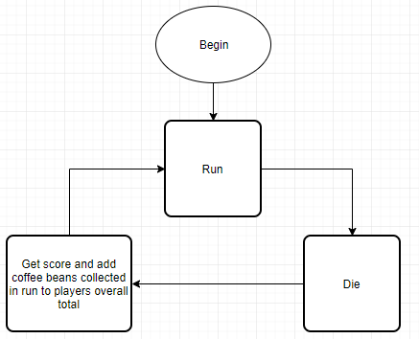

# **Game economy**

Coffee beans

* This currency is based in how many beans the player collects in the game. At the end of each run the beans collected are added to the players overall total. They can spend their beans on real life discounts for the client’s selection of coffee.

Score

* The further the player gets through the endless runner the higher the score they get, this is then compared against a global leaderboard and have the potential to gain a hefty reward based on their score.

# **Levels**

Because of the nature of an endless runner there aren’t any levels. What the game has are different biomes

Biome 1: mountains

* Assets will be slightly different (textures)
* The background will be a mountain range

Biome 2: desert

* Assets will be slightly different (textures)
* The background will be a desert.

# **Npcs, enemies and hazards**

Macino

* The big coffee grinder chasing the player

Hazards

* Broken pillar
* Rocks (different sizes)
* Pile of snow
* Falling rocks
* Fallen over tree
* Jumps between gaps
* Trees
* Logs
* Animal bones/rib cage
* Dead trees
* Sand stones
* Quick sand

# **Unlocks/ purchases**

**Real life rewards**

* 5% discount
* 10% discount
* 20% discount
* 25% discount
* 30% discount
* 35% discount
* 40% discount

# **Other known content.**

Text, speech, music, SfX, VFX, ect

* Sound effects (jumping sounds, landing, grunts, grinding coffee sounds)
* Music: royalty free intense chasing music (placeholder)
* Timed catch ups: periodically the coffee grinder will “catch up” on the player
* Animations for the player characters
* Having a female Beanbo for options

Leaderboards:

We want to get the company’s coffee out there into the hands of the public.

We have come up with idea of a leaderboard system that offers the top (x) people in (x) time prizes. We were thinking something on the lines of offering the top 500 player 5Kg of coffee.

In game notifications

* Your (x) meters from getting a free coffee
* You were (x) socre away from beign in the top 10 for a chance at free 5 kg of coffee
* Etc etc etc